**RAJ KUMAR GOEL INSTITUTE OF TECHNOLOGY & MANAGEMENT, GZB**

**First Sessional Examination 2017-18 ( Odd Semester)**

**Roll No.: Subject Name: CONTROL SYSTEM**

**Year/Branch**: **THIRD/EN Subject Code:NEE 503**

**Max Time: 1Hours 30 Minute Max Marks: 50**

**SECTION-A**

**Q.1 Attempt all parts carries equal marks. Write answer of each part in short. (2x5=10)**

**(a)**Define open loop and closed loop system with suitable examples.

**(b)** Explain the Masons Gain formula.

**(c)** Explain initial and final value theorem.

**(d)** Explain the standard test signals

**(e)** What is steady state error?

**SECTION-B**

**Note: Attempt any five questions from this section. (5x5=25)**

**Q.2**Obtain the closed loop transfer function C(S) / R(S) of the system using block diagram reduction technique whose block diagram is shown in figure.

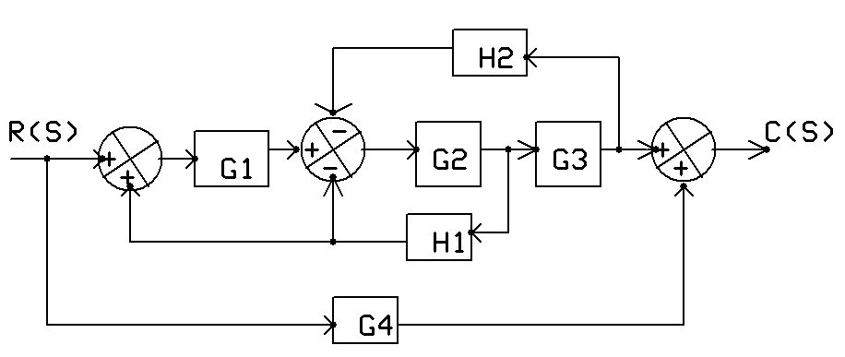

**Q.3** Derive the relationship between maximum overshoot and damping ratio of a second order system. Draw the graph or overshoot versus damping ratio.

**Q.4**Define and explain sensitivity of a control a system and also derive the sensitivity of overall transfer function with respect to G(s) and H(s).

**Q.57** Derive the expression of output response (c(t)) for unit step input of typical undamped & critically damped second order system.

**Q.6**A unity feedback system has an open loop transfer function G(s) = 10/(s(s+1)). Determine damping ratio, natural frequency and expression for the output response for unit step input.

**Q.7**Derive the expression of output response (c(t)) for unit step input of typical under-damped second order system.

**Q.8**Obtain the closed loop transfer function C(S) / R(S) of the system using block diagram reduction technique whose block diagram is shown in figure.



**Q.9** Obtain the closed loop transfer function C(S) / R(S) of the system using signal flow graph technique whose block diagram is given in Q.8.

**SECTION-C**

**Note: Attempt any two questions from this section. (7.5x2=15)**

**Q.10The** signal flow graph for a system is given below. Find the transfer function



**Q.11**The signal flow graph for a system is given below. Find the transfer function



**Q.12**The signal flow graph for a system is given below. Find the transfer function

